**DLD FINAL PROJECT**

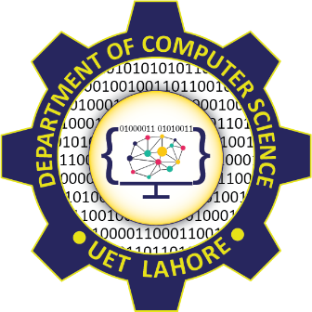

**Session 2023 - 2027**

**Submitted by:**

Sumaira Hafeez 2023-CS-1

Umar Saqi 2023-CS-2

Muhammad Ayan 2023-CS-5

Muhammad Mustafa 2023-CS-17

**Supervised by:**

Sir Tehseen

**Course:**

CSC-103 Object Oriented Programming

Department of Computer Science

**University of Engineering and Technology**

**Lahore Pakistan.**